FOR IMMEDIATE RELEASE

NEWS RELEASE May 31, 2014

CARIBBEAN ENDEMIC BIRD FESTIVAL SOARS TO NEW HEIGHTS

DATELINE — Over the past month, the 13th annual Caribbean Endemic Bird Festival (CEBF) was celebrated with dozens of events on over 20 Caribbean islands. This unique festival focuses on the bird species that are endemic to — found only in — the Caribbean. Each year, events organized as a part of this festival reach more than 80,000 participants throughout the region.

The festival is led by BirdsCaribbean [1], the largest organization devoted to wildlife conservation in the Caribbean. Organizations and coordinators on each island create events that reflect their unique birds and culture. The broad range of activities this year included guided bird walks, presentations in schools, art and photo contests, public lectures, radio and television shows, and outdoor events.

During the month-long festival, there were many highlights throughout the region. On Dominica, these included a bird art festival, birding field trips for schoolchildren, and a boat trip to see nesting seabirds. In Puerto Rico, a symposium was organized to highlight the role birds play in local ecosystems. Students in the Bahamas played a game to learn how different bird beaks are specialized for different foods, and students on Bermuda competed to build the best bluebird nesting boxes.

Even after over a decade, the festival continues to grow. On St. Martin, the first annual Endemic Animal Festival attracted hundreds to learn about endemic birds and other animals. St. Eustatius participated in the CEBF for the first time ever, with a day of activities including a bird walk, presentation, scavenger hunt and craft activities.

“Who pays the birds?” was the theme of this year’s festival, and festival activities explored the many benefits birds bring to both humans and nature. These benefits are numerous and diverse, from pollinating flowers and dispersing seeds to controlling agricultural pests and helping fishermen find fish. The role of attracting birdwatchers and other nature-loving tourists was of particular interest as many islands seek new markets for sustainable tourism growth.

“This year we really wanted to emphasize the environmental and economic value of birds in the region,” explains Leo Douglas, President of BirdsCaribbean. “When it comes to reducing the need for pesticides in agriculture, or helping islands tap into a nature tourism market worth billions of dollars, birds are our allies. In turn, recognizing the economic value of birds gives us an incentive to protect them and the habitats they depend on.”

The Caribbean is home to 150 species of bird that are considered endemic, or found nowhere else in the world. Many of these species live only on a single island, and many are endangered or threatened. These birds are the most unique examples of the Caribbean’s natural heritage, and they often occupy specialized niches in the ecology of the islands where they live. They may also be the key to attracting bird-loving tourists to the region.

“Over the years, thousands of students and residents have had the opportunity to enjoy and learn about local birds at CEBF events,” said Sheylda Díaz-Méndez, Regional Coordinator of the CEBF. “Raising awareness in Caribbean communities has always been the primary goal of this festival, but as it continues to grow we also find it is raising the profile of the Caribbean as both a birding destination and an international conservation priority.”

After a wildly successful 2014 festival, there are undoubtedly at least a few new bird enthusiasts out on the trail with binoculars in hand. Surely many people will look up and see a familiar bird in a new light, knowing it is unique to their island. Local coordinators will compare notes on which activities were most popular, and hopefully take a well-deserved break. Then the planning will begin for next year’s festival.

-------- ENDS --------

For more information, and to arrange an interview, please contact:

Sheylda N. Díaz-Méndez, Coordinadora, Festival de avesendémicas del Caribe (Regional Coordinator, Caribbean Endemic Bird Festival), Society for the Conservation and Study of Caribbean Birds, Tel: (787) 458-5406, Email: otoarina77@yahoo.com.
or
Scott Johnson (Media Relations Officer), BirdsCaribbean, Tel: 1 (242) 436-4380, Email: sjohnson@bnt.bs

NOTES TO EDITORS:
1. BirdsCaribbean is the largest regional organization devoted to wildlife conservation in the Caribbean. It is a non-profit organization whose goals are to promote the scientific study and conservation of Caribbean birds and their habitats, and to promote greater public awareness of the bird life of the region. For more details, see: www.birdscaribbean.org.

Photos and Captions (see attached high resolution photos):

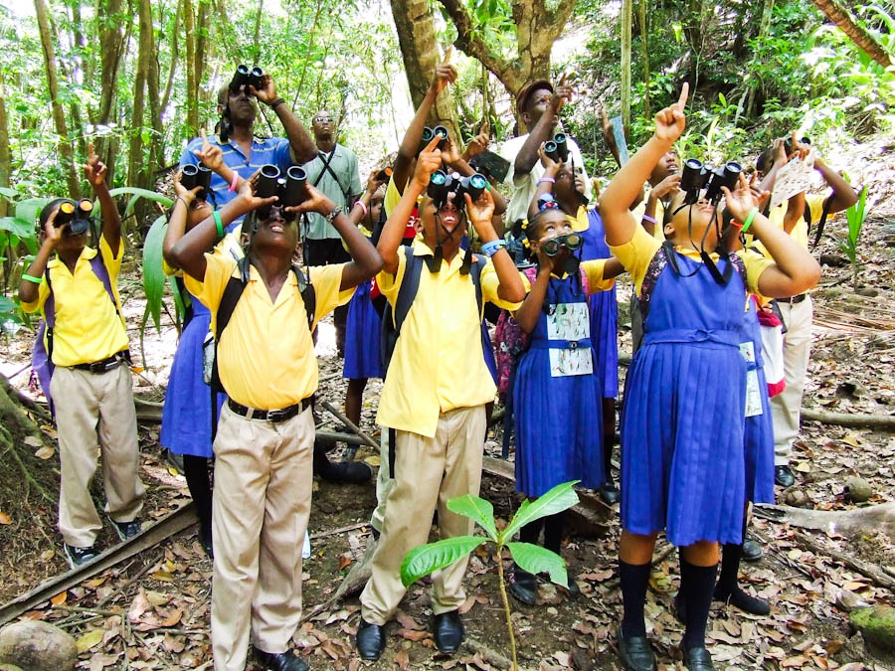
Caption: Primary school students go birdwatching on Dominica.

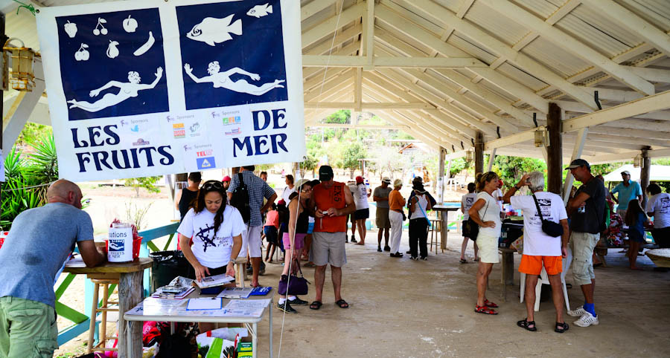
Caption: People of all ages attend the Endemic Animal Festival on St. Martin. Photo by Marc Petrelluzzi.

Caption: BirdsCaribbean member Andrew Dobson on the air giving a radio presentation on “Why Birds Matter.”

